Christian Isolda

Database Management

Lab 9

April 10, 2017

1. Functional Dependencies
   * People: PID🡪First Name, Last Name, Address, Phone number
   * Player: PlayID🡪 PID, Age
   * HeadCoach: HCID🡪 PID, years coached
   * AsstCoach: ACID🡪 PID, years coached
   * Group: GID🡪 ageRange
2. Draw a fully annotated E/R diagram using LucidChart that illustrates the Platonic ideal of beautiful and correct relational database design:

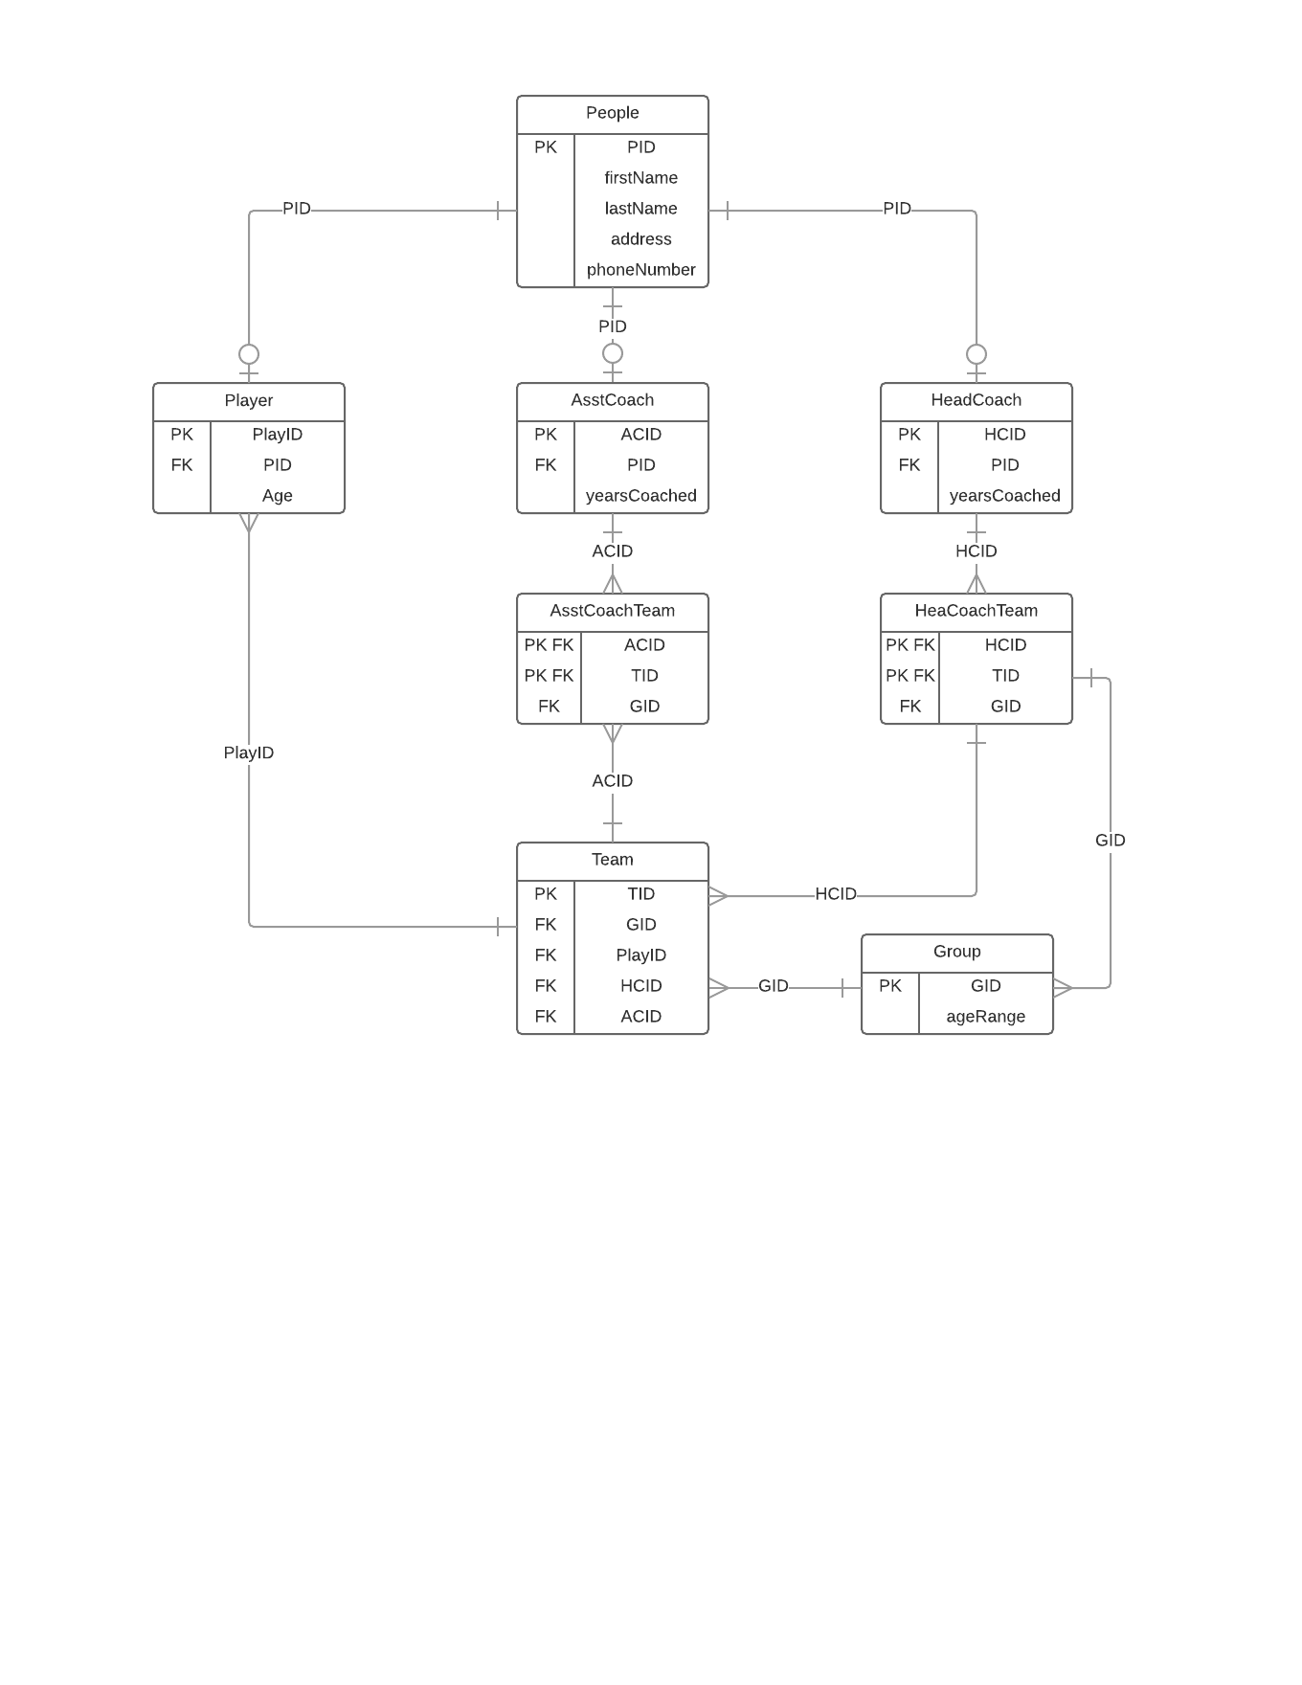

1. This database is in 3NF because it is also in 2NF and 1NF. Meaning that the database above is non redundant. Additionally, there are no functional dependencies other than the primary key for the tables. The tables make it organized and clean so the database can be clean and organized as well following the NF rules.